Woodchip Quality Manual
Version 4.0 - 2015

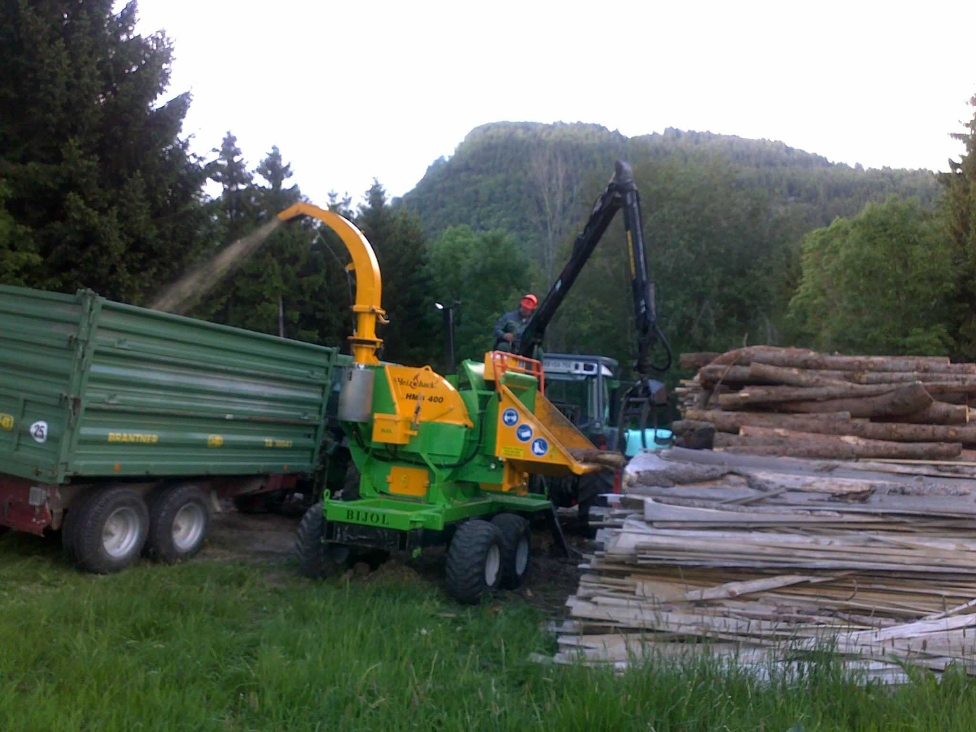

Introduction

The Wood Fuel Quality Assurance (WFQA) scheme for Ireland is an all island scheme established to increase consumer confidence in wood fuel products sold in Ireland.
WFQA certification ensures that suppliers of Firewood, woodchip, Woodpellets and wood briquettes are competent in producing woodfuel to correct standards, it also ensures that all raw material is sourced from sustainable sources and that product labelling ensures the customer gets all the required information.
The scheme is administered by an oversight committee comprising of fuel producers committed to the production of high quality wood fuel products and representatives from the Department of Agriculture Food and the Marine, Waterford IT and IrBEA (The Irish BioEnergy Association).

Reference for technical guides can be found in version 3 of this manual

Suppliers can join the WFQA by firstly contacting 01-4433636 or noelgavigan@irbea.ie

Wood Fuel Quality Assurance
Supplier Details

Company Name

Contact Person

Address
Phone
Email
Website
Fuel type supplied | Woodchip

Quality Policy Statement

Quality Policy
We supply fit for purpose wood chip fuel in order to meet customer quality and delivery requirements.
We are committed to good customer service and to addressing the needs and concerns of our customers promptly and professionally.
The wood chip supplied is fully traceable back to the land on which it was legally grown through full chain of custody tracking and we endeavour to supply wood fuel that is sourced from sustainably managed forests
We are committed to meeting legislative and regulatory requirements pertaining to our business operations.
We are committed to meeting all the requirements of the agreed national system for wood fuel quality set out in the National Workshop Agreement on Wood Fuel Quality Assurance, NWA 4:2009.
Fuel types supplied are described in Section 3 of the quality manual.
Our testing is designed and operated to meet the requirements in ISO EN 17225 Solid Biofuels Fuel Specifications and Classes part 4 Graded Woodchip
This manual is reviewed annually to respond to issues arising during the year with the aim of improving of our quality system. In particular any customer issues will be thoroughly investigated and rectified where necessary.

_____________________
Print Name

_____________________ _____________
Signed Date

2. Raw Material Sourcing

Applicants must demonstrate that all raw material is sourced from sustainably managed forests. All consignments of raw material must show documented evidence of sustainability. Proof of sustainability can be in the form of a Fellling Licence Number, WFQA certification, FSC certification or PEFC certification of the supplier.

Table 1: Raw Material Sourcing Declarations
Item | Initials
We maintain documented records of the origin of our raw material, these documents include information such as name and location of origin, and Felling Licence Number (alternatively WFQA, FSC or PEFC reference)

A record is kept for every consignment (load) from each location

No post-consumer/recycled wood (e.g. recycled pallets) is used

A record is kept of all wood (fuel or otherwise) that leaves the yard(s)

Signed:_____________________

3. Quality Control
Suppliers must show competence to produce woodchip to EN17225-4 or other standard as agreed.

Normative requirements of EN 17225-4
Table 2.1 – Particle size of graded wood chips
Dimensions (mm), ISO 17827-1
Main fraction  (minimum 60 w-%), mm ª |  | Fines fraction, w-% (≤ 3,15 mm) | Coarse fraction, w-%,  (length of particle, mm) | Max. length of particles ^{b}, mm | Max. cross sectional area of the coarse fraction ^{c}, cm²)
P16S | 3,15 mm < P ≤ 16 mm | ≤ 15 % | ≤ 6 % (> 31,5 mm) | ≤ 45 mm | ≤ 2 cm²
P31S | 3,15 mm < P ≤ 31,5 mm | ≤ 10 % | ≤ 6 % (> 45 mm) | ≤ 150 mm | ≤ 4 cm²
P45S | 3,15 mm < P ≤ 45 mm | ≤ 10 % | ≤ 10 % (> 63 mm) | ≤ 200 mm | ≤ 6 cm²
ª The numerical values (P-class) for dimension refer to the particle sizes passing through the mentioned round hole sieve size (ISO 17827-1). The lowest possible class should be stated. Only one class shall be specified for wood chips.
^{b} Length and cross sectional area only have to be determined for those particles, which are to be found in the coarse fraction.
Maximum 2 pieces of a 10 litre sample may exceed the maximum length, if the cross sectional area is < 0,5 cm².
^{d} For measuring the cross sectional area it is recommended to use a transparent template, place the particle orthogonally behind the template and estimate the maximum cross sectional area of this particle with the help of the cm²-pattern.

Table 2.2 - Specifications for Graded Wood Chips*
 | Property Class  Analysis Method | Unit | A |  | B
 |  |  | 1 | 2 | 1 | 2
Normative | Origin and Source  ISO 17225-1 |  | 1.1.1 Whole trees without roots  1.1.3 Stemwood  1.1.4 Logging residues  1.2.1 Chemically untreated wood residues | 1.1.1 Whole trees without roots  1.1.3 Stemwood  1.1.4 Logging residues  1.2.1 Chemically untreated wood residues | 1.1 Forest, plantation and other virgin wood (excluding stumps and bark)  1.2.1 Chemically untreated wood residues | 1.1 Forest, plantation and other virgin wood (excluding stumps and bark)  1.2 By-Products and residues from wood processing industry  1.2.1 Chemically untreated wood residues
 | Particle Size, P  ISO 17827-1 | Mm | To be selected from Table 2.1 |  | To be selected from Table 2.1
 | Moisture, M  ISO 18134-1  ISO 18134-2 | w-% | M10 < 10  M25 < 25 | M35 <35 | Maximum value to be stated
 | Ash A  ISO 18122 | w-% dry | A1.0 < 1.0 | A1.5 < 1.5 | A3.0 <3.0
 | Bulk Density  ISO 17828 | Kg/loose m3 as received | BD 150 > 150  BD 200 > 200  BD 250 > 250 | BD 150 > 150  BD 200 > 200  BD 250 > 250  BD 300 > 300 | Minimum value to be stated
*transposed from EN 17225-4

Table 3: Quality Parameters to be controlled under WFQA

Parameter | Control Factors/methods | Recommended Test Method | Standard required | Initials
Particle Size | Chipper screens, blade sharpness. Material to be chipped | Bucket sieves | P16s, P32s, P45s or other as per ISO EN 17225-1
Moisture Content | Adequate seasoning of wood to required level | Oven test for verification,  Moisture probe for indicative testing as per WFQA Competent Skills Guide 1 | M20 (>20%)  M25 (>25%)  M30, M35, M40, M45, M50, M55, M60, M65, M65+
Bulk Density | Quality of raw material | Weight of container of known volume | BD 150, BD200, BD250, BD300
Weight | N/A | Weighbridge/ Weigh cells | Calibrated weighbridge / weigh cells

Signed:_____________________

4. Labelling/information Requirements
All woodchip sold under the WFQA must comply with the WFQA information requirements. Customers must be provided with key information describing the woodchip. This information may be contained on the delivery docket or an information sheet going with the delivery docket.
(Note example label in section 6 of this document)
Table 4: Labelling Requirements
Parameter | Required under | Requirement | Initials
Supplier details | WFQA | Supplier name, address and contact details are required on labels. Exceptions may be made where product is bagged on behalf of other suppliers
WFQA Stamp | WFQA | Display of suppliers WFQA stamp mandatory
Country of Origin | WFQA | Country must be displayed
Origin (virgin wood) | WFQA /  EN 17225-4 | Label to state “This product is made from virgin timber”
Wood Species | WFQA /  EN 17225-4 | Minimum statement that product is hardwood or softwood
Moisture Class | WFQA /  EN 17225-4 | Display appropriate class as per EN 17225-4  (See Table 2.2)
Particle Size | WFQA /  EN 17225-4 | Display appropriate class as per EN 17225-4  (See Tables 2.1 and 2.2)
Bulk Density | WFQA /  EN 17225-4 | Display appropriate class as per EN 17225-4  (See Table 2.2)
Weight | WFQA /  EN 17225-4 | Weight information from calibrated weighbridge or weighcells
Customer Information | WFQA | Display “Ensure woodchip is stored in dry conditions and your boiler & flue are maintained to manufacturers specifications”

Signed:_____________________

5. Management

Item | Signature/initials
Scheme Requirements
We hold a current Tax Clearance Certificate
We hold a Health and Safety Statement relevant to our wood processing operation
We hold Public Liability Insurance for our wood processing operations
Record Keeping
All Records are kept for a minimum of 2 years

All relevant records will be made available for WFQA audit

Relevant records will be made available to customers
(management retains the right to refuse access where it is believed that customer or commercial confidentiality could be compromised)
Customer Complaints and Feedback
All customer complaints and feedback are recorded and dealt with within 14 days. Details such as those listed in the example Complaints and Feedback sheet (section 6 of this document) are all recorded.
Management ensure all complaints are dealt with promptly and any remedial action required is taken within 14 days. These actions are also recorded.
Management Review
Management conduct an annual review of this Quality system, all data in the records are reviewed and trends identified that may point to less than acceptable quality and less than acceptable quality management. Management ensure the Quality system is in compliance with the quality manual
All non-compliances and customer complaints are reviewed, any remedial action taken is assessed for effectiveness

Signed:_____________________ Date:_____________

6. Example Record Sheets and Product label

WFQA suppliers are free to record required information in a manner that suits their own needs, however we have provided below some examples which can be used if required.
Record Sheet 1: Raw Material IN (timber loads)
Load number | Date | Forest name/Owner | Forest location | Felling Licence Number | Species | Weight (tonnes) | Volume m³ | Estimated Moisture Content | Destination (Stack number) | Comments

Record Sheet 2: Oven Moisture Test
Sample No | Sample Taken (date) | Moisture Meter reading | Oven Test
 |  |  | Tray weight | Weight 1 (W1) (without Tray) | Weight 2 (W2) (without Tray) | MW (Moisture Weight) = W1-W2 | %M.C. (MW / W1 X 100)

Sample No | Sample Taken |  | Date/Time of test | Customer |  |  | Species
 |  |  |  |  |  |  |  |  |  |  | Moisture Test
 |  |  |  |  |  |  |  |  |  |  | Tray Wt | W1 (without Tray) | W2 (without Tray) |  | MW (W1-W2) | %M.C. (MW÷W1 X 100)
Fraction | Fines fraction, (≤ 3,15 mm) |  | on 3.15mm screen | on 16mm screen | on 31.5mm screen |  | on 45mm screen |  |  | on 63mm screen | Max particle length (mm) in 10 Litre sample | Max. cross sectional area, cm2 (coarse fraction)
Weight |  |  |  |  |  |  |  |  |  |  | mm | cm2
Total
% |  |  |  |  |  |  |  |  |  |  |  |  |  | Class | Compliance | RESULT ( only lowest numbered class)
P16 | <15% |  | Minimum 60% |  |  | Max 6% larger than 31.5mm |  |  |  |  | Max 45mm | < 2cm2 |  | P16S | Yes / No
P31 | <10% |  | Minimum 60% |  |  |  |  | Max 6% larger than 45mm |  |  | Max 150mm | < 4 cm2 |  | P31S | Yes / No
P45 | <10% |  | Minimum 60% |  |  |  |  |  |  | Max 10% larger than 63mm | Max 200mm | < 6 cm2 |  | P45S | Yes / No
Signed: |  |  |  |  |  |  | Date:

Record Sheet 4: Customer Feedback and Complaints
Date | Customer Contact information (Name, Address, Phone) | Customer complaint |  | Person Responsible for dealing with issue | Cause and Remediation required | Remediation Complete & effective (date) | Customer Notified (Date)

Example Product Data Sheet

WOODCHIP
Weight 15000kg
Wood Type Softwood
Moisture Content M35 (Less than 35% Moisture content)
Particle Size P45s
Bulk Density B250

Produced from virgin Irish timber sourced from sustainably managed forests by A Woodchip Company, A Town, A Country. Phone 011-98765
www.AWoodFuelCompany.ie

Ensure woodchip is stored in dry conditions, and your boiler and flue are maintained to manufacturer’s specifications.

