Firewood Quality Manual
Version 4.1 - 2016

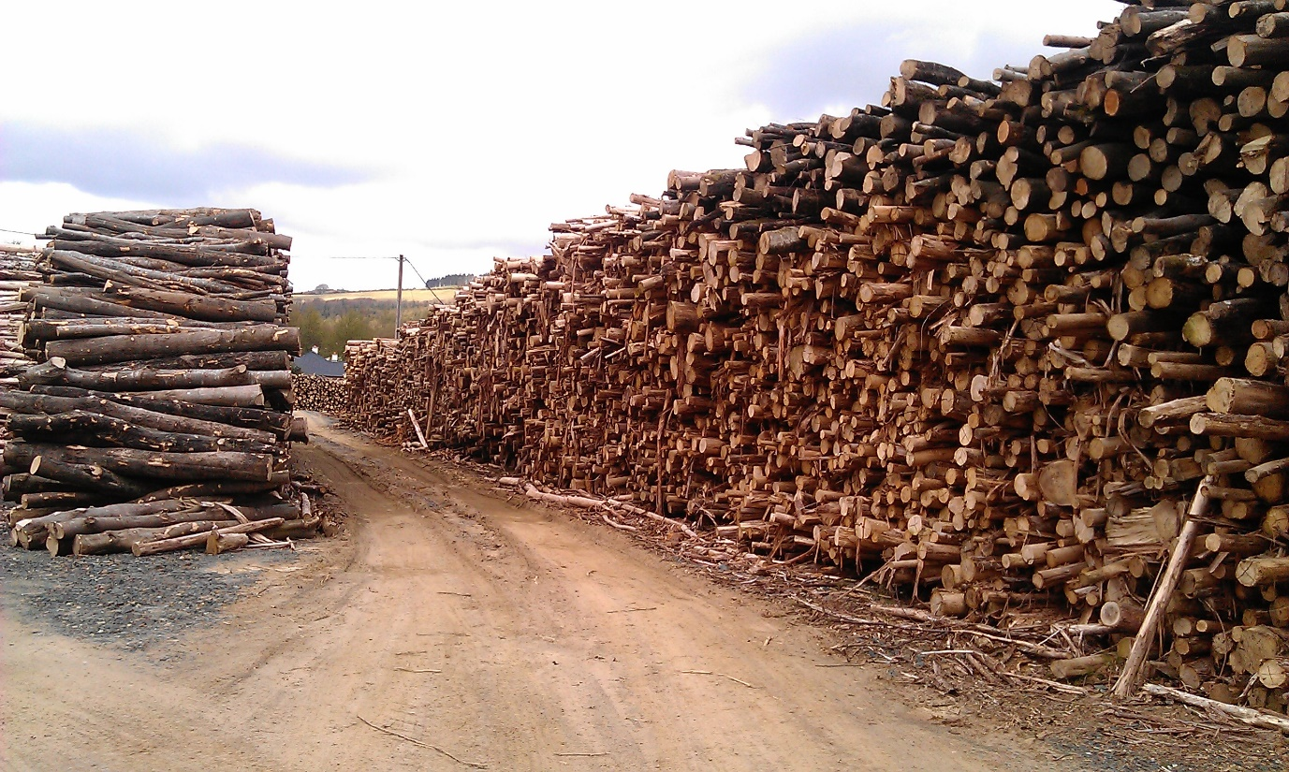

Introduction

The Wood Fuel Quality Assurance (WFQA) scheme for Ireland is an all island scheme established to increase consumer confidence in wood fuel products sold in Ireland.
WFQA certification ensures that suppliers of Firewood, woodchip, Woodpellets and wood briquettes are competent in producing woodfuel to correct standards, it also ensures that all raw material is sourced from sustainable sources and that product labelling ensures the customer gets all the required information.
The scheme is administered by an oversight committee comprising of fuel producers committed to the production of high quality wood fuel products and representatives from the Department of Agriculture Food and the Marine, Waterford IT and IrBEA (The Irish BioEnergy Association).

Suppliers can join the WFQA by firstly contacting 01-4433636 or noelgavigan@irbea.ie

Wood Fuel Quality Assurance
Supplier Details

Company Name

Contact Person

Address
Phone
Email
Website
Fuel type supplied | Firewood

Quality Policy Statement

Quality Policy
We supply fit for purpose firewood in order to meet customer quality and delivery requirements.
We are committed to good customer service and to addressing the needs and concerns of our customers promptly and professionally.
The firewood supplied is fully traceable back to the land on which it was legally grown through full chain of custody tracking and we endeavour to supply wood fuel that is sourced from sustainably managed forests
We are committed to meeting legislative and regulatory requirements pertaining to our business operations.
We are committed to meeting all the requirements of the agreed national system for wood fuel quality set out in EN ISO 177225-5 Fuel Specifications and Classes - Firewood.

Moisture content of the fuel supplied will be in accordance with the ISO EN 17225-5 quality class A1 and A2, we adhere to the maximum moisture content of 25% outlined in this quality class for bagged product.
Our testing is designed and operated to meet the requirements in ISO EN 17225 Solid Biofuels Fuel Specifications and Classes part 5 Graded firewood
This manual is reviewed annually to respond to issues arising during the year with the aim of improving of our quality system. In particular any customer issues will be thoroughly investigated and rectified where necessary.

_____________________
Print Name

_____________________ _____________
Signed Date

2. Raw Material Sourcing
Applicants must demonstrate that all raw material is sourced from sustainably managed forests. All consignments of raw material must show documented evidence of sustainability. Proof of sustainability can be in the form of a Fellling Licence Number, WFQA certification, FSC certification or PEFC certification of the supplier.

Table 1.1: Raw Material Sourcing Declarations
Item | Initials
We maintain documented records of the origin of our raw material, these documents include information such as name and location of origin, and Felling Licence Number (alternatively WFQA, FSC or PEFC reference)

A record is kept for every consignment (load) from each location

No post-consumer/recycled wood (e.g. recycled pallets) is used

A record is kept of all wood (fuel or otherwise) that leaves the yard(s)

Table 1.2: Raw Material Import
Item | Initials
We operate in the European Single Market and in general the movement of goods is not restricted.
We understand that the importation of certain species is restricted under the EU Plant Health Directive. Importation of Sweet Chestnut, Platanus and all conifers is restricted. Ireland has additional restrictions on the import of Ash.
As per Department of Agriculture rules we will notify the Department of any proposed import of firewood/raw material in advance via email to forestprotection@agriculture.gov.ie The Department will then issue an all clear where we are free to import / or a restriction where the species is restricted. We will maintain records of this correspondence for WFQA audit.

Signed:_____________________

3. Quality Control
Suppliers must show competence to produce firewood to EN17225-5 or other standard as agreed.

Table 2: Normative requirements of EN 17225-5
 | Property class,  Analysis method | Units | A1 | A2 | B
Normative | Origin and source,  ISO EN 17225-1 |  | 1.1.3 Stemwood  1.2.1 Chemically untreated wood residues | 1.1.1 Whole trees without roots  1.1.3 Stemwood  1.1.4 Logging residues  1.2.1 Chemically untreated wood residues | 1.1.1 Whole trees without roots  1.1.3 Stemwood  1.1.4 Logging residues  1.2.1 Chemically untreated wood residues
 | Wood species ª |  | To be stated |  | To be stated
 | Diameter, D ^{b} | cm | D2 ≤ 2  D5 2 < D < 5  D15 5 < D <15  D15+ >15 (actual value to be stated) |  | D15 5 < D ≤15  D15+ >15 (actual value to be stated)
 | Length, L^{c} | cm | L20 ≤ 20 (± 2 cm)  L25 ≤ 25 (± 2 cm)  L30 ≤ 30 (± 2 cm)  L33 ≤ 33 (± 2 cm)  L40 ≤ 40 (± 2 cm)  L50 ≤ 50 (± 4 cm)  L100 ≤ 100 (± 5 cm) |  | L30 ≤ 30 (± 2 cm)  L33 ≤ 33 (± 2 cm)  L40 ≤ 40 (± 2 cm)  L50 ≤ 50 (± 4 cm)  L100 ≤ 100 (± 5 cm)
 | Moisture, M ^{d}  ISO EN 18134-1,  ISO EN 18134-2 | w-% as received  wet basis | M20 ≤ 20  M25 ≤ 25 |  | M20 ≤ 20  M25 ≤ 25  M35 ≤ 35
 | Volume or weight | Volume m³ stacked or loose or weight, kg  as received | To be stated which unit is used when retailed (m³ stacked or loose, kg) and/or packaged log woods weight.
ª Wood species (e.g. spruce, birch, beech) can be stated by using EN 13556 Round and sawn timber Nomenclature^{[8]}. If firewood includes different wood species, the main wood species should be mentioned first.
^{b} 85 % of the firewood should be kept in specified diameter property class. For stoves it is recommended to use firewood with a diameter less than 15 cm. D2 and D5 are recommended for cookers and as kindling (ignition wood).
^{c} It is allowed to have 15 % firewood shorter than requested length including the limit value.
^{d} Moisture content should not be less 12 w-% on wet basis (M) or 13,64 w-% on dry basis (U).
^{e} The energy density (E) may be calculated according to Annex D on the basis of the bulk density (BD) and the net calorific value .
^{f} Use of chainsaw and circular saw will give a smooth and even cut-off surface.

Table 3: Quality Parameters to be controlled under WFQA

Parameter | Control Method | Recommended Test Method | Standard required | Initials
Diameter | Operator training to achieve required size | Random checks with 50mm X 150mm guide as per WFQA Competent Skills Guide 2 | D2, D5 (Kindling) D15, D15+ (Firewood)  as per table 2
Length | Firewood processor stop plate | Random checks with measuring tape | L20, L25, L30, L33, L40, L50, L100  as per table 2
Moisture Content | Adequate seasoning of wood to required level | Oven test for verification,  Moisture probe for indicative testing as per WFQA Competent Skills Guide 1 | M20 (>20%)  M25 (>25%)
Weight / Volume | Fixed volume bag filler or weight control | Random weight checks | 100% compliance with indicated weight/volume

Signed:_____________________

4. Labelling Requirements
All firewood sold under the WFQA must comply with the WFQA labelling requirements. Labels can be affixed to bags/packaging, or in the case of whole pallets or bulk deliveries direct to the consumer a product data sheet with the required information may accompany the delivery.
New entrants to the scheme will be given maximum 9 months to meet labelling requirements to allow time to design and order labels with the (newly acquired) WFQA stamp.
(Note example label in section 6 of this document)
Table 4: Labelling Requirements
Parameter | Required under | Requirement | Initials
Supplier details | WFQA | Supplier name, address and contact details are required on labels. Exceptions may be made where product is bagged on behalf of other suppliers
WFQA Stamp | WFQA | Display of suppliers WFQA stamp mandatory
Country of Origin | WFQA | Country must be displayed
Origin (virgin wood) | WFQA /  EN 17225-5 | Label to state “This product is made from virgin timber”
Wood Species | WFQA /  EN 17225-5 | Minimum statement that product is hardwood or softwood
Moisture Class | WFQA /  EN 17225-5 | Display appropriate class as per EN 17225-5  (See Tables 2&3)
Diameter and Length class | WFQA /  EN 17225-5 | Display appropriate class as per EN 17225-5  (See Tables 2&3)
Volume / Weight | WFQA /  EN 17225-5 | Display weight or volume of firewood
Customer Information | WFQA | Display “Ensure firewood is stored in dry conditions and your stove/appliance is maintained to manufacturers specifications. In the case of open fires ensure that a spark guard is used.”

Firewood may also be labelled as class A1,A2 or B as per Table 2.

Signed:_____________________

5. Management

Item | Signature/initials
Scheme Requirements
We hold a current Tax Clearance Certificate
We hold a Health and Safety Statement relevant to our wood processing operation
We hold Public Liability Insurance for our wood processing operations
Record Keeping
All Records are kept for a minimum of 2 years

All relevant records will be made available for WFQA audit

Relevant records will be made available to customers
(management retains the right to refuse access where it is believed that customer or commercial confidentiality could be compromised)
Customer Complaints and Feedback
All customer complaints and feedback are recorded and dealt with within 14 days. Details such as those listed in the example Complaints and Feedback sheet (section 6 of this document) are all recorded.
Management ensure all complaints are dealt with promptly and any remedial action required is taken within 14 days. These actions are also recorded.
Management Review
Management conduct an annual review of this Quality system, all data in the records are reviewed and trends identified that may point to less than acceptable quality and less than acceptable quality management. Management ensure the Quality system is in compliance with the quality manual
All non-compliances and customer complaints are reviewed, any remedial action taken is assessed for effectiveness

Signed:_____________________

6. Example Record Sheets and Product label

WFQA suppliers are free to record required information in a manner that suits their own needs, however we have provided below some examples which can be used if required.
Record Sheet 1: Raw Material IN (timber loads)
Load number | Date | Forest name/Owner | Forest location | Felling Licence Number | Species | Weight (tonnes) | Volume m³ | Estimated Moisture Content | Destination (Stack number) | Comments

Record Sheet 2: Oven Moisture Test
Sample No | Sample Taken (date) | Moisture Meter reading | Oven Test
 |  |  | Tray weight | W1 (without Tray) | W2 (without Tray) | MW (Moisture Weight) = W1-W2 | %M.C. (MW / W1 X 100)

Record Sheet 3: Customer Feedback and Complaints
Date | Customer Contact information (Name, Address, Phone) | Customer complaint |  | Person Responsible for dealing with issue | Cause and Remediation required | Remediation Complete & effective (date) | Customer Notified (Date)

Example Product Label

FIREWOOD
Weight 8kg
Wood Type Softwood
Moisture Content M25 (Less than 25% Moisture content)
Length L20 (20cm +/-2cm)
Diameter D15 (5-15cm)

Produced from virgin Irish timber sourced from sustainably managed forests by A Firewood Company, A Town, A Country. Phone 011-98765
www.AWoodFuelCompany.ie

Ensure firewood is stored in dry conditions, your stove/appliance is maintained to manufacturer’s specifications and your chimney/flue is properly cleaned.
Ensure that a spark guard is used at all times or that stove doors are kept closed.

